**The Copilot AI**

**3. Explore real-word implementation**

I asked! How to create an automated pet feeder system with Arduino Uno and Raspberry pi?

There are too many responses its break down step by step for the system requirement and compered the option between Adruino Uno and Raspberry pi. Which one you offer and fit for you.

It was helpful, because the explanations are provide many details got some idea from that. Still not much useful to influenced the problem and solution.

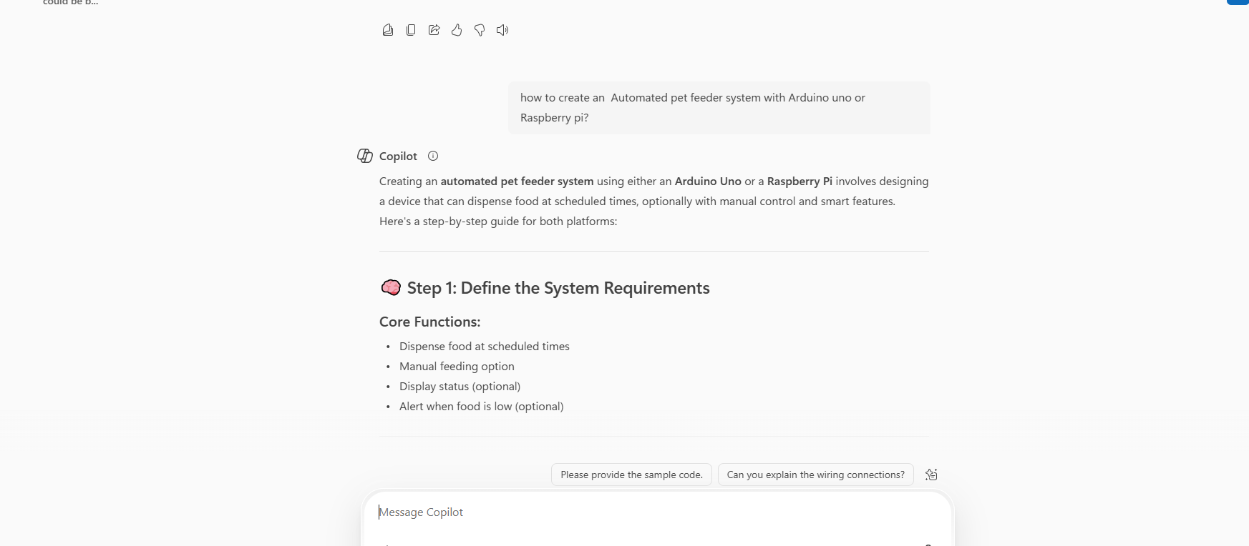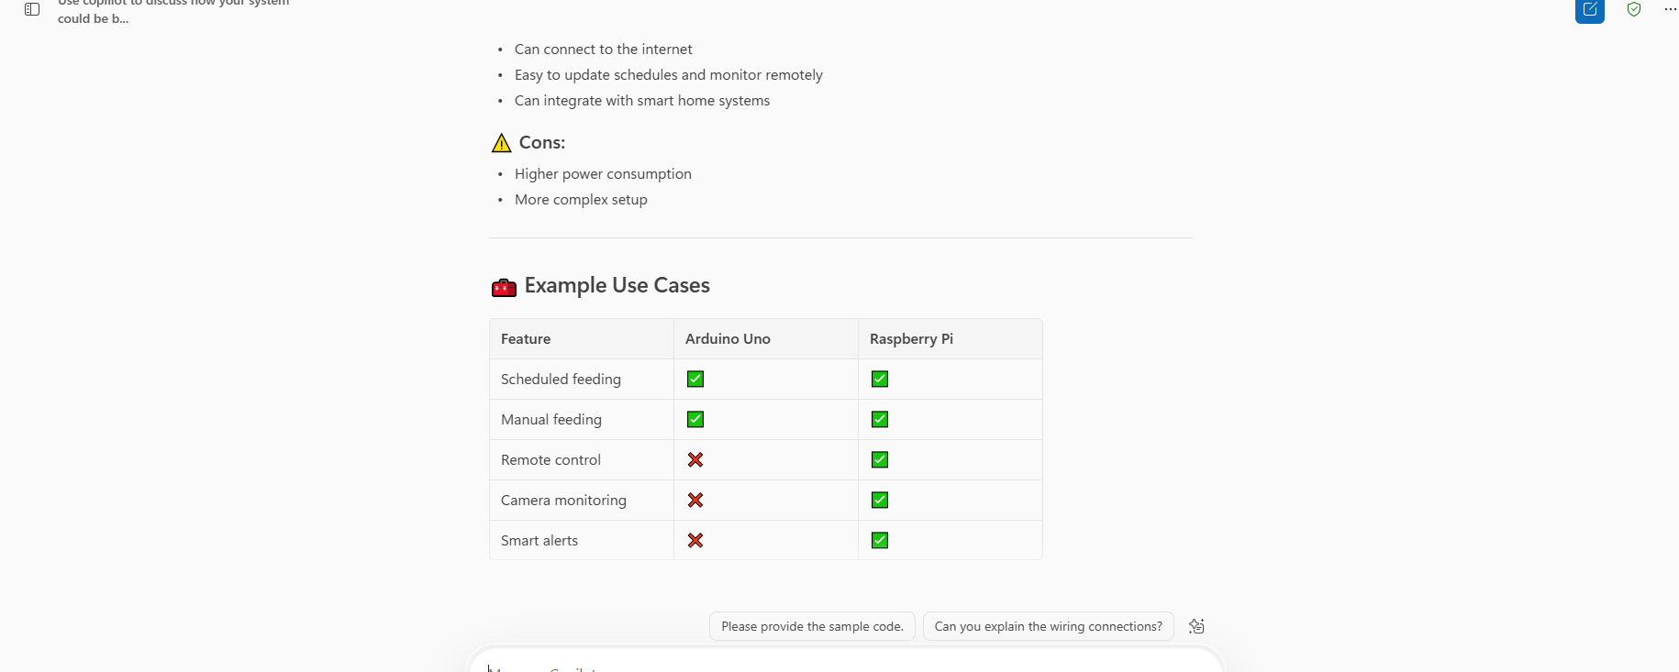

**4. Improve documentation**

I asked! Write a professional README.md file the automated pet feeder system project for me?

It rapidly been created the README.md file able to download it and many details provided more than expected but some information not influenced understanding, because need to lean the basic logic to get some idea. It not exactly what we need to know. It was what AI can collect information available in there and must be ask specific question to get exactly answer AI.



